

**Imam Mohammad ibn Saud Islamic University**

**College of Computer and Information Sciences**

**Information Systems Department**

**AOUN**

**By:**

Saleh Jamal Almutairi, 442015756, 076, Group 06

Yazeed Ayman Kordi, 442020048, 076, Group 06

**Supervised by:**

Prof. Abdul Kader Jilani Saudagar

Project Submitted in Fulfillment for the IS496 Course requirements

Semester-Year



**Imam Mohammad ibn Saud Islamic University**

**College of Computer and Information Sciences**

**Information Systems Department**

**AOUN**

**By:**

Saleh Jamal Almutairi, 442015756, 076, Group 06

Yazeed Ayman Kordi, 442020048, 076, Group 06

|  |  |
| --- | --- |
| **Supervisor Name** | Prof. Abdul Kader Jilani Saudagar |
| **Date** |  |
| **Signature** |  |

**تعهد**

أتعهد بعدم المشاركة في الفعاليات أو المبادرات أو المسابقات ذات العلاقة دون أخذ موافقة خطية مسبقة من الكلية، و أقر بمعرفتي أنني إذا خالفت هذا التعهد ستتم محاسبتي وفق اللوائح و الأنظمة.

|  |  |  |
| --- | --- | --- |
| إسم الطالب | الرقم الجامعي | التوقيع |
|  |  |  |
|  |  |  |
|  |  |  |
|  |  |  |

# Declaration

We Saleh Jamal Almutairi / 442015756, and Yazeed Ayman Kordi / 442020048 being members of final year project group number 06, declare that this report contains only work completed by members of our group except for information obtained in a legitimate way from literature, company or university sources. All information from these other sources has been duly referenced and acknowledged in accordance with the University Policy on Plagiarism.

Furthermore, we declare that in completing the project, the individual group members had the following responsibilities and contributed in the following proportions to the final outcomes of the project:

|  |  |  |  |
| --- | --- | --- | --- |
| **Student ID** | **Responsibilities[1]** | **Contribution[2] %** | **Signature** |
| 442020048 | Team Leader | 50% |  |
| 442015756 | Team Member | 50% |  |

# Dedication

Sample:

To my family

[Not to the Supervisor !]

# Acknowledgment

[Express your appreciation to who have helped during your work, acknowledge your supervisor’s contribution as well.]

Sample:

First and foremost, we would like to present our deepest gratitude to Almighty

ALLAH for his bounties and blessings and for giving us the ability to finish this project

We would like to express our deep appreciation and our sincere gratitude to our supervisor [SUPERVISOR NAME] for [HIS/HER] valuable advice guidance throughout this project.

Finally, we would like to thank our families and friends for continued encouragements and support during this project and along the years of study.

# Abstract

The Aoun Cooperative Training System aims to develop an application that consolidates all companies, students, and faculty into a single application. This application will facilitate students in finding suitable cooperative opportunities and automate the process of submitting files for all parties involved. From the student's perspective, the application allows for easy file submission. From the company's perspective, it enables the review and approval of submissions before they are sent to the faculty. From a faculty perspective, the application allows for the review and evaluation of submissions.

The methodology chosen for this project is the waterfall model. This approach was selected to aid in the comprehensive planning and analysis of the current and future systems. The project began with the planning phase, where the team discussed the project idea and the problem it aims to solve. This was followed by the analysis phase, which involved gathering the necessary requirements through stakeholder interactions, including brainstorming sessions, interviews, and questionnaires.

The outcome of this project is a redefined and reengineered business process for applying to cooperative training, as well as a streamlined process for cooperative training itself. The main driving functionalities of the system have been clearly defined to ensure its success. Overall, the Aoun application aims to address many discrepancies within the current system, streamline processes, and reduce the number of steps unnecessary involved in cooperative training for all parties involved.

# Abstract (in Arabic)

*نظام التدريب التعاوني* **عُون Aoun** *يهدف إلى تطوير تطبيق يجمع جميع الشركات والطلاب وأعضاء هيئة التدريس في منصة واحدة. سيتيح هذا النظام للطلاب إيجاد فرص تدريب تعاوني مناسبة ويتمتع بالقدرة على تقديم الملفات بشكل آلي لجميع الأطراف المعنية.من جهة الطالب، يسمح التطبيق بتقديم الملفات بسهولة. ومن جهة الشركة، يمكنهم مراجعة وموافقة على الملفات قبل إرسالها إلى أعضاء هيئة التدريس. ومن جهة أعضاء هيئة التدريس، يتيح التطبيق مراجعة وتقييم الملفات.*

*المنهج المختار لهذا المشروع هو نموذج الشلال. تم اختيار هذا النهج للمساعدة في التخطيط الشامل والتحليل للأنظمة الحالية والمستقبلية. بدأ المشروع بمرحلة التخطيط، حيث ناقش الفريق فكرة المشروع والمشكلة التي يهدف إلى حلها. بعد ذلك مرحلة التحليل، التي تضمنت جمع المتطلبات اللازمة من خلال تفاعلات مع أصحاب المصلحة، بما في ذلك جلسات التفكير الجماعي والمقابلات والاستبيانات.*

*نتيجة هذا المشروع هي عملية أعمال معرفة وهندسة جديدة للتقديم على التدريب التعاوني، بالإضافة إلى عملية مبسطة للتدريب التعاوني نفسه. تم تحديد وظائف النظام الرئيسية بوضوح لضمان نجاحه. بشكل عام، يهدف تطبيق* **عُون Aoun** *إلى معالجة العديد من التناقضات داخل النظام الحالي، وتبسيط العمليات، وتقليل عدد الخطوات غير الضرورية المشاركة في التدريب التعاوني لجميع الأطراف المعنية.*

# Keywords

* Web Application.
* Management System.
* Cooperative Training.
* Aoun Application.
* Automate Report management.
* Information Systems.
* Requirement Gathering.
* Waterfall Approach.
* Work Breakdown Structure.
* Gantt Chart.
* Use Case Analysis.
* Functional Requirements.
* Non-functional Requirements.

# List of Abbreviations

**SDLC:** Software Development Life Cycle.

**CO-OP:** cooperative

**IS:** Information System.

**UI:** User Interface.

**GDP:** Graduate Development Program.

**OS:** Operating System.

**BPMN:** Business Process Model and Notation

**WBS:** Work Breakdown Structure

**HR:** Human Resources

**MoSCow:** M - Must have, S - Should have, C - Could have, W - Won’t have.

**CV:** Curriculum Vitae

**CLO:** course learning outcome

# Table of Contents

Declaration iii

Abstract iv

Abstract (in Arabic) v

Keywords vi

List of Abbreviations vii

Table of Contents viii

List of Figures x

List of Tables xi

Chapter 1: Planning 1

1.1 Project Overview 2

1.2 Problem Statement 3

1.3 Project Impact 4

1.4 Project Stakeholders 4

1.4.1 Students 4

1.4.2 Faculty 4

1.4.3 Companies 5

1.5 Objectives 5

1.6 Approach 6

Planning Phase 7

Analysis Phase: 7

Design Phase 7

Development Phase 7

Deployment Phase 7

1.7 Project Scope 8

1.8 Work Breakdown Structure 9

1.9 Gantt Chart (Time Frame) 10

1.10 Team Member's Responsibilities 11

Chapter 2: Background Analysis 13

2.1 Possible Solutions 14

2.1.1 The first possible solution is an "independent application 14

2.1.2 The second possible solution involves a "Manual process for co-op training" 14

2.2.3 The third possible solution is an application called "AOUN application." 14

2.2 Overview of Existing systems 16

2.2.1 Manual Process of co-op training program 16

2.2.2 Independent applications 17

2.2.3 Aoun Improvements 18

2.3 Existing Business Processes 18

2.3.1 Applying for Co-op Training Process 19

2.3.2 Co-op Training Process 19

Chapter 3: Requirements Analysis 20

3.1 Requirement Gathering Summary Results 21

3.1.1 Interview Summary Results 22

3.1.2 Questionnaire Summary Results [See Appendix A] 24

3.1.3 Brainstorming summary Results 24

3.2 Stakeholder Requirements 25

3.2.1 Student Requirements 25

3.2.2 Faculty Requirements 25

3.2.3 Companies Requirements 26

3.3 Proposed Business Process 27

3.3.1 Aoun Applying for co-op training process. 27

3.3.2 Aoun co-op training process 28

3.4 Functional Requirements 29

3.4.1 Use Case diagram 29

3.4.2 Use Case description 30

3.5 Non-functional Requirements 36

Chapter 4: System Design 8

4.1 System Modelling 9

4.1.1 Activity diagrams 9

4.1.2 Class Diagram 9

4.1.3 Sequence Diagrams 9

4.2 Data Modelling 9

4.2.1 ER Diagram 9

4.2.2 Data Dictionary 9

4.3 Detailed Interface Design 9

4.4 Component Diagram [optional] 9

Chapter 5: System Implementation 10

5.1 System Specification 11

5.1.1 Hardware Specifications 11

5.1.2 Software Specifications 11

5.2 System Testing 11

5.2.1 Features to be tested 11

5.2.2 Test Cases 11

5.3 System Deployment 11

5.3.1 Deployment Diagram 11

5.3.2 Expected Users/Load 11

5.3.3 Installation Process 11

Chapter 6: Conclusion and Future Work 12

6.1 Conclusion 13

6.2 Future Work 13

References 37

Appendix 38

A. Questionnaire results 38

A. Miscellaneous 42

B. Presentation Slides 44

# List of Figures

Figure 1:Waterfall Approach. 6

Figure 2: WBS. 9

Figure 3: Gantt Chart 10

Figure 4: Hayerd. 17

Figure 5: Applying for co-op training. 19

Figure 6:Co-op Training Process. 19

Figure 7: Aoun applying for Co-op training process. 27

Figure 8:Aoun co-op training process. 28

Figure 9: AOUN use case. 29

# List of Tables

Table 1: Team Responsibilities 12

Table 2:Cost-Benefit Analysis. 15

Table 3:Registration use case. 30

Table 4: Feedback use case. 31

Table 5: Company search use case. 32

Table 6: File submission use case. 33

Table 7:Offer co-op use case. 34

Table 8:Manage users use case. 35

Table 9: Faculty interview form 42

Table 10: Company Interview Form 43

# Chapter 1: Planning

## 

## 1.1 Project Overview

Aoun application is designed to streamline the process of finding cooperative training opportunities for university students nearing graduation. By bridging the gap between students and companies, Aoun simplifies the search and application process, making it more efficient for both parties.

With Aoun, students can effortlessly search and apply to companies offering cooperative training programs that align with their academic background and career aspirations. The application provides a centralized application to explore various opportunities, ensuring students find placements that are a perfect fit for their skills and goals.

Aoun serves as a valuable resource for companies seeking talented and eager trainees from universities. By posting training opportunities on the Aoun application, companies can specify their requirements and await applications from qualified students. This not only enhances the visibility of their programs but also streamlines the selection process.

Aoun functionality extends beyond merely connecting students with training opportunities. Once a student secures a placement, the application facilitates ongoing communication and feedback between the company's trainers and the student's university supervisor. Trainers can submit weekly reports or other necessary documentation directly through Aoun, enabling supervisors to monitor the student's progress and provide support as needed.

Aoun application represents a comprehensive solution for students and companies involved in cooperative training programs. By simplifying the search, application, and feedback processes, Aoun ensures that students can maximize their learning experiences, while companies benefit from a streamlined approach to finding and nurturing talent.

## 1.2 Problem Statement

The core issue driving the development of the Aoun Project is the significant gap in the accessibility and management of cooperative training opportunities for students nearing graduation. This gap manifests in two primary challenges: first, the lack of a centralized application where students can discover organizations offering co-op positions relevant to their field of study; and second, the inconvenient process of submitting and managing weekly reports for both students and supervisors.

The consequences of not addressing this problem are multifaceted and far-reaching. For students, this gap represents a missed opportunity in gaining vital hands-on experience, enhancing their employability, and bridging the theory-practice divide that is crucial for their transition into the workforce. For educational institutions and employers, the inefficiency and lack of coordination can result in a talent mismatch, underutilization of eager and capable students, and ultimately, a slower pace in addressing the skills gap in various industries.

The need for a solution like the Aoun application is underscored by evidence from academic studies and labour market analyses that highlight the growing importance of cooperative education. For instance, research indicates that students who participate in co-op programs are more likely to secure employment upon graduation, often with higher starting salaries [1]. Additionally, organizations that provide cooperative training opportunities report higher retention rates among employees who participated in these programs as students, underscoring the mutual benefits of such initiatives [2].

By facilitating easier access to cooperative training opportunities and streamlining the reporting and management process, the Aoun Project aims not only to enhance the educational outcomes for students but also to contribute to a more skilled and ready-to-work graduate pool. This, in turn, supports the broader goal of strengthening the link between academia and industry, thereby fostering a more dynamic and responsive workforce.

## 1.3 Project Impact

Upon implementation, our Application is positioned to majorly impact the Information Systems (IS) department. By providing a comprehensive framework to enhance Co-op programs, we aim to create a more professional and skilled workforce, better equipped to meet the needs of modern companies. This initiative not only strengthens individual students' skills but also contributes to the overall advancement of the IS field.

On a global scale, our ambition is to establish our application as the standard across all universities worldwide. The broad implementation will revolutionize recruitment practices globally, ensuring a more effective and efficient matching of talent with opportunities. By bridging the gap between academia and industry, our application will play a integral role in shaping the future workforce, making it more agile, and ready for the challenges of the future.

## 1.4 Project Stakeholders

### 1.4.1 Students

The **Aoun** application is primarily intended to benefit students, with a focus on student-centered design. For students, the application creates new opportunities by streamlining the Co-op training program application process. It successfully resolves the issues with the present application system, such as the inability to find opportunities, guaranteeing that students may efficiently and easily apply for training programs.

### 1.4.2 Faculty

Faculty members with the correct tools to systematically supervise and review students, promoting a structured approach that fosters a conducive environment for continuous student improvement. This systematic approach not only enhances the quality of supervision but also creates opportunities for faculty to provide targeted feedback and support, leading to a more enriching training experience for students. By facilitating a better environment for constant evaluation, the application plays a pivotal role in the holistic development of students, ensuring they are well-prepared for their future endeavors.

### 1.4.3 Companies

**AOUN** optimizes the registration of co-op programs for companies, simplifying the process of discovering suitable student candidates, sanctioning efficient acceptance or rejection workflows. It enables easy scheduling and conduction of follow-up interviews, all while significantly reducing the reliance on hard copies and signatures for weekly or monthly reviews. This solution is designed to enhance the professionalism and success of co-op program management.

## 1.5 Objectives

**AOUN** goal is to help students find cooperative training easily, as well as help companies find students for training, and this is done by achieving the following objectives:

* Enhance the co-op program application and training for students to access and utilize co-op training opportunities by enabling a smooth process between companies and students.
* Streamline the administration of co-op programs for trainers by creating strong, three-way channels of communication between companies, faculty, and students.
* Optimize the co-op evaluation process that enables faculty members to review evaluations, organizing the students’ evaluation process, and allows trainers to approve forms submitted by students, ensuring thorough assessment and continuous improvement.

## 1.6 Approach

In our project, we adopted the waterfall approach, which is a traditional methodology and methodology within the software development life cycle (SDLC). The waterfall model is known for its linear and sequential progression, which ensures that all phases are completed before the next one starts, thus creating a clear structure for our project execution. This method has been proven to be effective in various software engineering and product development projects, making it an ideal choice for achieving our goals.

The reasons why we chose the waterfall approach is that the requirements are clear and well-known, and the solution to our problem is straightforward.

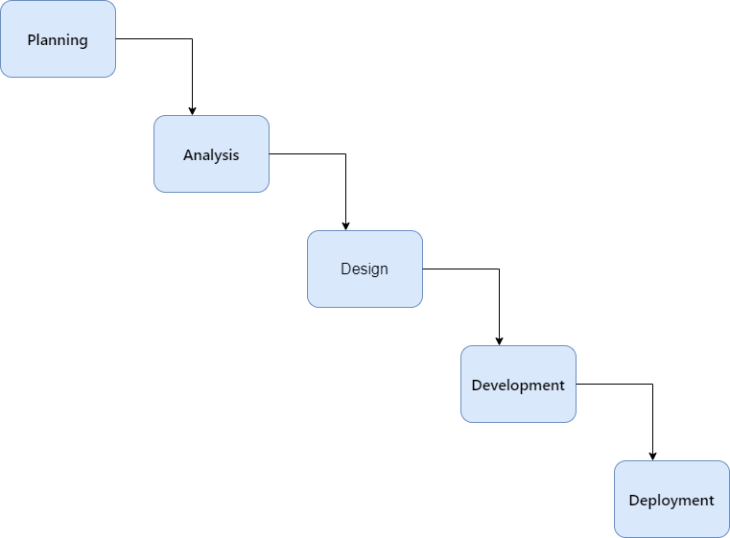

Figure 1:Waterfall Approach.

Planning Phase**:** This stage involves thorough discussions to define our project idea and the problem we aim to solve. We evaluate the system's benefits, drawbacks, and expected performance, aiming to align our goals with user needs and expectations.

Analysis Phase: We will collect system requirements through stakeholder interactions, employing brainstorming, interviews, and questionnaires. Our objective is to create a complete list of requirements, guaranteeing that the final product meets all user necessities.

Design Phase**:** Next, we will analyze the requirements to understand them deeply, translating this information into a structured model for guiding subsequent design and development.

Development Phase**:** With a clear understanding of requirements, our development phase involves coding and building the project components as per specifications, focusing on collaboration, problem-solving, and iteration.

Deployment Phase**:** The project is launched in the deployment phase, transitioning it to a real-world setting and marking the start of its operational life. This phase is crucial for delivering our solution.

Our goal throughout the Waterfall model is to maintain high quality and efficiency standards, while delivering a product that exceeds user expectations and effectively solves the identified problem.

## 1.7 Project Scope

The project focuses on the development of a comprehensive application tailored to facilitate the application process for students seeking co-op training programs. This application will also serve as a registration portal for companies looking to offer co-op opportunities, all under the compass of the IS department. Notably, the application does not extend to providing graduates with GDP (Graduate Development Program) or other similar services.

Communication channels will be established to facilitate three-way interactions between students, companies, and faculty members exclusively. This approach’s goal is to create a focused and efficient system for the management of co-op positions.

To ensure a fair and structured process, students will be required to apply for co-op positions and await acceptance based on their resumes, the application will not grant students co-op opportunities freely.

## 1.8 Work Breakdown Structure

We utilized the Work Breakdown Structure (WBS) to segment the project into smaller, manageable phases, facilitating easier execution and ensuring high-quality outcomes.

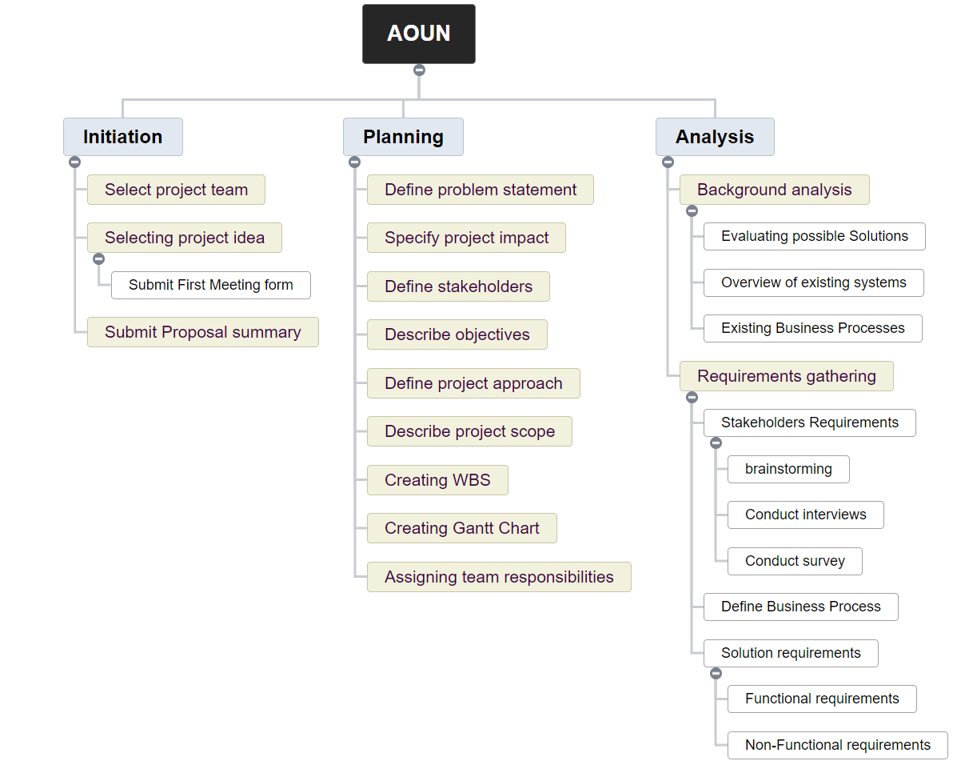

Figure 2: WBS.

## 1.9 Gantt Chart (Time Frame)

The Gantt chart plays a critical role in our project, as it is developed based on the Work Breakdown Structure (WBS) outlined in section 1.8. This ensures a structured approach to managing timelines and tasks.

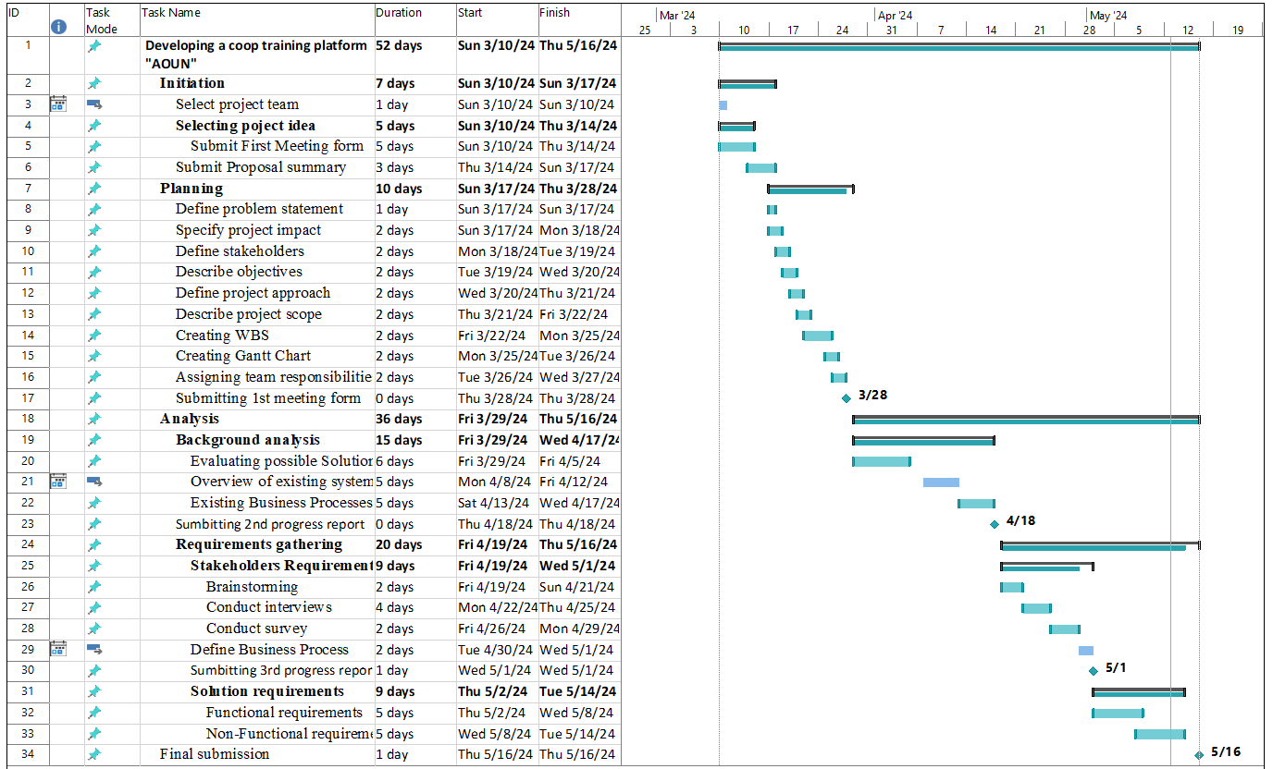

Figure 3: Gantt Chart

## 1.10 Team Member's Responsibilities

|  |  |
| --- | --- |
| Task | Student responsible |
| **1.Planning** | |
| 1.1 Define problem statement | Saleh |
| 1.2 Specify project impact | Yazeed |
| 1.3 Define stakeholders | Yazeed |
| 1.4 Describe objectives | Saleh & Yazeed |
| 1.5 Define project approach | Saleh |
| 1.6 Describe project scope | Yazeed |
| 1.7 Creating WBS | Saleh & Yazeed |
| 1.8 Creating Gantt Chart | Saleh & Yazeed |
| 1.9 Assigning team responsibilities | Saleh |
| **2.Analysis** | |
| * 1. **Background analysis** | |
| 2.2.1 Evaluating possible Solutions | Saleh |
| 2.2.2 Overview of existing systems | Yazeed |
| 2.2.3 Existing Business Processes | Yazeed |
| 2.2.3.1 Existing BPMN | Saleh & Yazeed |
| **2.3 Requirements gathering** | |
| 2.3.1 Stakeholders Requirements | |
| 2.3.1.1 brainstorming | Saleh & Yazeed |
| 2.3.1.2 Conduct interviews | Saleh & Yazeed |
| 2.3.1.3 Conduct survey | Saleh & Yazeed |
| 2.3.2 Define Business Process | Saleh & Yazeed |
| 2.3.3 Solution requirements | |
| 2.3.3.1 Functional requirements | Saleh & Yazeed |
| 2.3.3.1 Non-Functional requirements | Saleh & Yazeed |

Table 1: Team Responsibilities

# Chapter 2: Background Analysis

## 

## 2.1 Possible Solutions

2.1.1 The first possible solution is an "independent application [1]" This is a website that enables companies to offer co-op training opportunities and students to apply for them. This website does not offer a feature to submit or manage weekly reports.

2.1.2 The second possible solution involves a "Manual process for co-op training" This traditional approach requires students to search for co-op training opportunities manually. Similarly, the submission and management of weekly reports are conducted manually, with reports typically submitted in hard copy.

2.2.3 The third possible solution is an application called "AOUN application." This application is a website developed under the Information System Department's umbrella. It facilitates students' search and application process for companies offering cooperative (co-op) training. Additionally, once a student is accepted for co-op training, trainers can upload the required weekly reports about the student. This allows the student's university supervisor to review the reports submitted by the trainer.

|  |  |  |  |  |
| --- | --- | --- | --- | --- |
| Criteria | Independent application | Manul process for co-op training | Aoun application | |
| Benefit | | | | |
| 1. Automate Report management | × | × | √ | |
| 1. Esay to use | √ | × | √ | |
| 1. Integration with University Systems | × | × | √ | |
| 1. Simplicity of Tools | × | × | × | |
| 1. Scalability | √ | × | √ | |
| 1. Customization | √ | × | √ | |
| 1. Data Accuracy | √ | × | √ | |
| 1. Functional suitability | × | × | √ | |
| 1. Maintainability | √ | × | √ | |
| 1. Feedback process | × | √ | √ | |
| COST | | | | |
| 1. Cost Development | Medium | Low | | Low |

Table 2:Cost-Benefit Analysis.

## 2.2 Overview of Existing systems

### 

### 2.2.1 Manual Process of co-op training program

The current system starts off by retrieving papers from the field training website [3] and choosing certified program alternatives from a dropdown menu are the first steps in the co-op application process. Then, using a variety of resources, students look for opportunities that fit their needs. They give the supervisor a co-op training plan if they decide on an uncertified curriculum. The supervisor receives weekly progress reports, and site visits may be undertaken as part of the review process. Three crucial forms are completed to signify the conclusion of the co-op training program.

**Advantages of Current System:**

* Cost-effective
* Perceived simplicity from an outsider's perspective

**Disadvantages:**

* Excessive complexity leading to confusion.
* Potential issues with document stamping
* Management challenges due to numerous participants

### 2.2.2 Independent applications

Using different applications for Example: Hayerd [4] ,to look for co-op opportunities, independent application enables people to investigate a variety of options outside of those offered by a particular program. Nevertheless, this method has drawbacks, like having to navigate websites that offer options for every major, which can make it more difficult to find the best positions. Upon identification of an opportunity, the user is frequently redirected to the company website to complete additional application procedures.

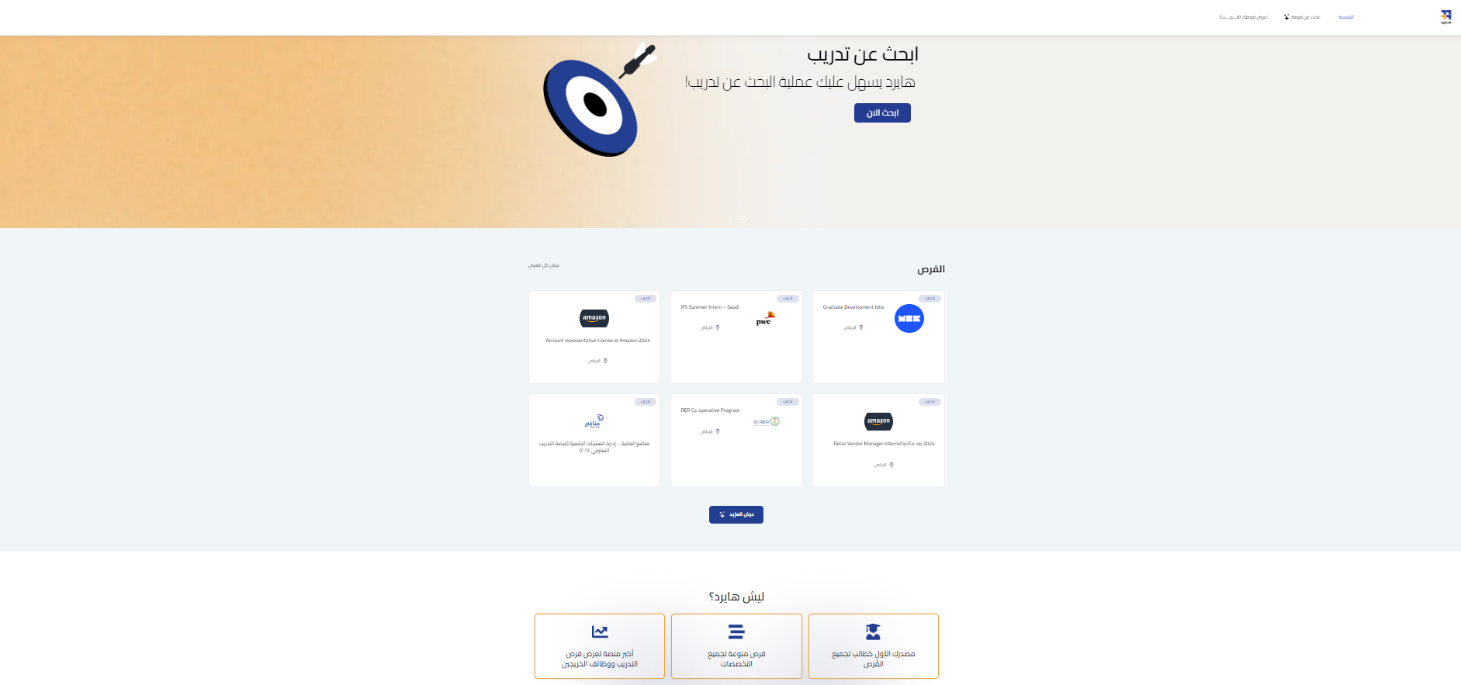

Figure 4: Hayerd.

**Advantages:**

* Possibility of finding opportunities outside of one's major, enhancing career exploration and range.

**Disadvantages**:

* Weekly reporting features are not integrated, which makes progress tracking difficult.
* Lack of a centralized platform for interactions between students, department, and companies, which hinders the efficiency and streamlining of the application process.

### 2.2.3 Aoun Improvements

Establishing a comprehensive application that integrates co-op application, submissions, and facilitating company communication, the proposed “AOUN” project seeks to address these drawbacks. This centralized solution will transform the co-op application landscape by streamlining procedures, reducing inconsistencies, and improving user experience.

## 2.3 Existing Business Processes

The current system is started off by retrieving documents from the field training website is the first manual step in the process of establishing a co-op application. The website features a dropdown menu that makes choosing programs easier by providing certified options. After that, students search for appropriate possibilities using a variety of venues, such as social media and independent co-op websites.

If a student opts for a program that is not on the certified list, they must gain a co-op training schedule and submit it to the supervisor. After then, a form called a joining report needs to be filled out, A significant drawback arises if the HR (Human Resource) department fails to stamp the form, necessitating the cumbersome step of informing them to send it via mail to the relevant department.

Students communicate with their co-assignee immediately after identifying them; this person is usually a faculty member acting as the supervisor. Weekly progress reports are delivered via Blackboard, hardcopy, or any other method the supervisor deems appropriate. They include tasks, activities, and training materials. To evaluate the student's development, supervisors may also ask for site visits, which will facilitate communication with the HR and management departments.

Three crucial forms must be completed at the end of the program: an attendance form, a detailed final report detailing the full experience, and a report intended for direct managers or team leads. The co-op training program is completed upon submission of these forms.

We used BPMN (Business Process Model and Notation) diagrams [5] to outline the systems and processes that students engage with. The first BPMN diagram illustrates the procedure students follow to obtain the necessary forms before starting their training and applying to companies. The second BPMN diagram details the co-op training process, including the steps for submitting required reports.

2.3.1 Applying for Co-op Training Process

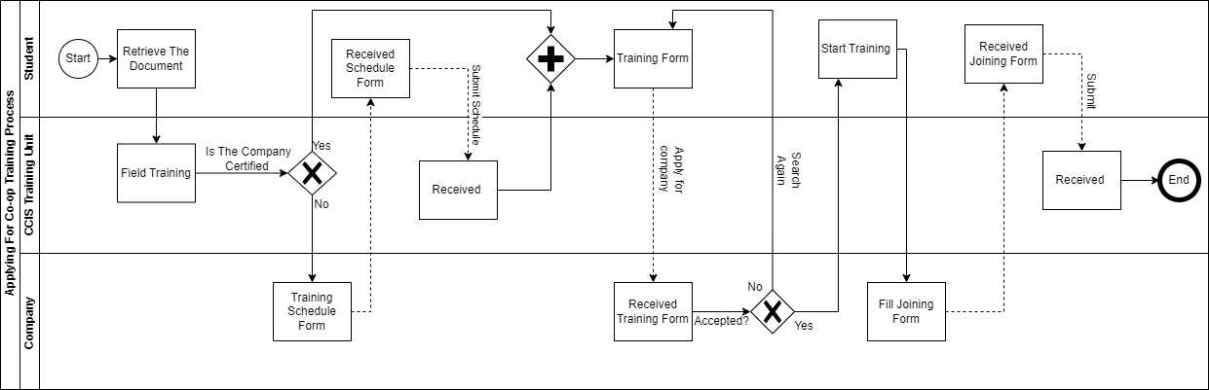

Figure 5: Applying for co-op training.

2.3.2 Co-op Training Process

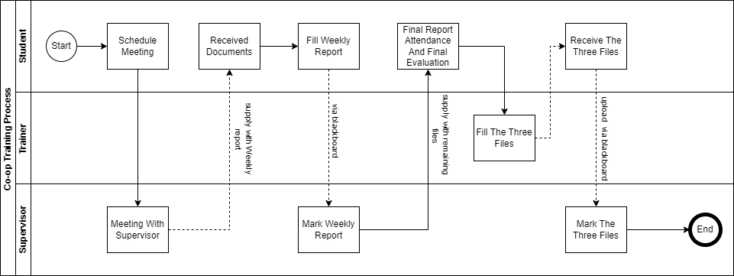

Figure 6:Co-op Training Process.

## 

# 

# Chapter 3: Requirements Analysis

## 3.1 Requirement Gathering Summary Results

To define the requirements for the **AOUN** application, we utilized three different techniques. Firstly, we conducted brainstorming sessions to generate ideas and identify crucial features for the application. Secondly, we interviewed stakeholders from three different companies and five faculty members to gain insight into their specific challenges and needs. Lastly, we distributed questionnaires to students who had completed their co-op training to obtain a wide range of feedback on the challenges they are faced and the features they value the most.

We used the **MoSCoW** **[6]** method to prioritize the requirements which is method that is particularly useful for effectively managing time and resources. This technique helps teams to differentiate between the essential and non-essential features of a project.

**- Must have (M):** These are the most important and non-negotiable requirements that are critical to the system's core functionality. The project will be considered a failure if these requirements are not completed, so they must be included in the final product.

**- Should have (S):** These features are important but not vital to the project's success. They should be included in the final product if possible, but they can be postponed if necessary.

- **Could have (C):** These features are desirable but not necessary. If time and budget allow, they can be included to improve the user experience or customer satisfaction.

**- Won't have this time (W):** These requirements are the least critical or those that have been deliberately excluded from the current project scope. They might be considered in the future, but they are not necessary for the current delivery.

### 3.1.1 Interview Summary Results

To collect crucial feedback for the AOUN application, we reached out to 15 companies via email and LinkedIn. Unfortunately, only three companies responded positively to our request. However, we were able to conduct thorough interviews with these companies to gain a better understanding of their unique needs and challenges.

**Company X requirements:**

Company x is a tier 4 company in the Artificial Intelligence industry, they mainly deliver products and services for physical activity.

**Challenges:** Company X faces significant challenges in their recruitment process, specifically in finding students who possess the necessary skills for their operations. They have expressed concerns about the effectiveness of traditional CVs (Curriculum Vitae) and profiles in showcasing a candidate's abilities.

**Desired Features:** Company X would like to integrate a feature into the AOUN application that allows students to upload video presentations or interviews. This feature would help recruiters at Company X assess communication skills and get a better understanding of the applicant's personality and suitability for their work environment.

**Company Y requirements:**

Company Y is a tier 1 company in the retailing industry, they are focused on retailing home furniture.

**Challenges:** Company Y is limited by the current system, which only allows them to offer co-op training during certain periods of the year, leading to missed opportunities for both students and the company. Additionally, they struggle to find students who meet their skill requirements.

**Desired Features:** Company Y wants the AOUN application to support open and flexible registration periods for co-op training, making it easier to match company needs with student availability. They also want enhanced profiles that include detailed information about students' skills, majors, and areas of interest to streamline the recruitment process.

**Company Z requirements:**

Company z is a tier 1 company, one of the most significant companies in the middle east selling dairy and juice products.

**Challenges:** Company Z finds LinkedIn inadequate for their specific needs as it often fails to provide sufficient student details necessary for initiating contact. This forces them to rely on universities to provide comprehensive student information, which can be time-consuming and inefficient.

**Desired Features:** Company Z is interested in a direct channel within the AOUN application that provides full access to student information, including contact details, facilitating easier outreach and communication with potential candidates.

**Faculties Requirements**

We have conducted interviews with four faculty members from the college to evaluate their needs and challenges with the current coop training process. One of the interviewees was from the female section, and the other 3 were from the male section.

All interviewees expressed concerns about the existing system's inefficiency and the lack of automation in handling required documentation for students. They all suggested that the current system needs to be re-engineered to streamline processes.

Furthermore, the faculty members emphasized the need for improved communication tools. They suggested integrating real-time chat and email messaging features within the AOUN application to facilitate easier supervision and more effective communication with companies hosting students. These enhancements aim to simplify oversight and improve the overall management of students.

### 3.1.2 Questionnaire Summary Results [See Appendix A]

As part of the process to gather requirements for our project, we sent a questionnaire to students who had completed their co-op training. We asked them 6 key questions to understand how they currently search for co-op opportunities and the challenges they face with existing systems. We also asked about the specific difficulties they encountered and how our proposed AOUN application could help address them and simplify the process. We were pleased to find that 100% of the respondents believed that the AOUN application could effectively resolve the current system's shortcomings and improve the search process. We also gathered their opinions on the desired features for the AOUN application to ensure that it aligns with their needs and expectations.

### 3.1.3 Brainstorming summary Results

We organize brainstorming sessions together to think of new ideas and identify important features for the Aoun application. Our goal is to completely change the way Co-op training is done to make it better. In these sessions, we share our thoughts and suggestions, and we write down all the ideas. After gathering all the ideas, we use the MoSCoW method to decide which features are the most important to work on first. This method helps us focus on the most necessary features, making sure we are spending our time and resources on improvements that will make the biggest difference.

## 3.2 Stakeholder Requirements

### 3.2.1 Student Requirements

1. The student must be able to create profile.
2. The student must be able to apply for companies.
3. Student must be able to view when the company training positions are open for hiring.
4. Student must be able to attach the required documents for Co-op training.
5. Student must see their application status.
6. Student should be able to filter the opportunities that the companies offer.
7. Student should be able to view the number of positions available.
8. Student should view the needed skills for the required position.
9. Student could only use one application for Co-op training.
10. Student could view company profile.
11. Student could be able to view tutorial for Co-op training process.
12. Student could be able to upload a video for interview purpose.
13. Student could write feedback on their previous experience.
14. Student could check-in for his attendance.
15. Student could specify if he has earned the job after training.

### 3.2.2 Faculty Requirements

1. Faculty must be able to create profile.
2. Faculty must be able to view the status of students.
3. Faculty must view the files submitted by students.
4. Faculty must be able to give the dates of submission of the reports.
5. Faculty must mark the files submitted by students.
6. Faculty should be able to document meeting minute.
7. Faculty could be able to check if the students have achieved CLOs.
8. Faculty could communicate with company through real-time messaging.

### 3.2.3 Companies Requirements

1. Company must be able to create profile.
2. Company must be able to offer Co-op Training.
3. Company must be able to view the student profile.
4. Company must be able to upload the training schedule.
5. Company trainer must be able to modify and approve the documents submitted by students.
6. Company should be able to offer Co-op Training at any period.
7. Company should be able to filter student based on their major and skills.
8. Company could verify student attendance.

## 3.3 Proposed Business Process

The proposed systems as seen below for the applying process will begin by the student and the company will both need to register. The business will then offer co-op positions. The student has access to these positions and can apply. After reviewing the applications, the company will determine which students to accept or reject. Students can return to the list of co-op positions and reapply for other positions if they are rejected. The company must provide a joining report form to the training unit if a student is approved. After that, the student can begin training.

The co-op training process assumes that the student and company are already registered. It begins with the faculty member registering. Then, the faculty member will be assigned to the student. The student will submit weekly reports, which the company will review and add notes to. The supervisor will mark the reports, and the student will receive feedback. This process also applies to the final report submission. Finally, after the student has completed the co-op training program, they will be able to review their experience.

### 3.3.1 Aoun Applying for co-op training process.

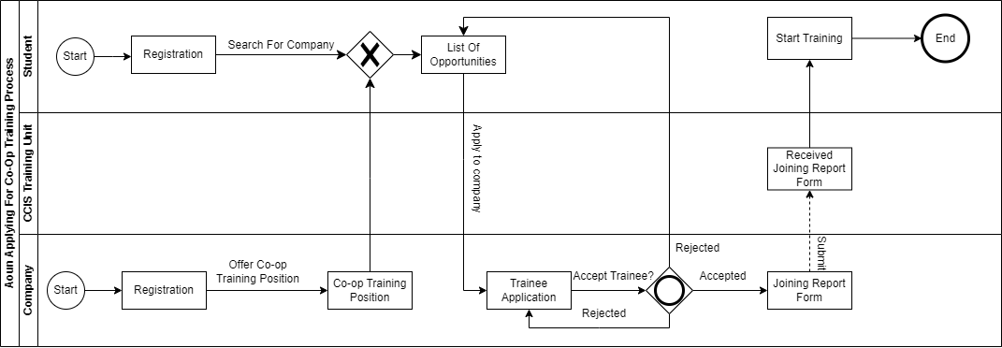

Figure 7: Aoun applying for Co-op training process.

### **3.3.2 Aoun co-op training process**

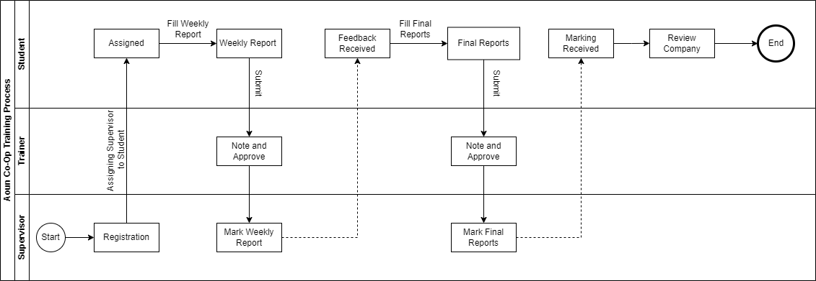

Figure 8:Aoun co-op training process.

## 3.4 Functional Requirements

### 3.4.1 Use Case diagram

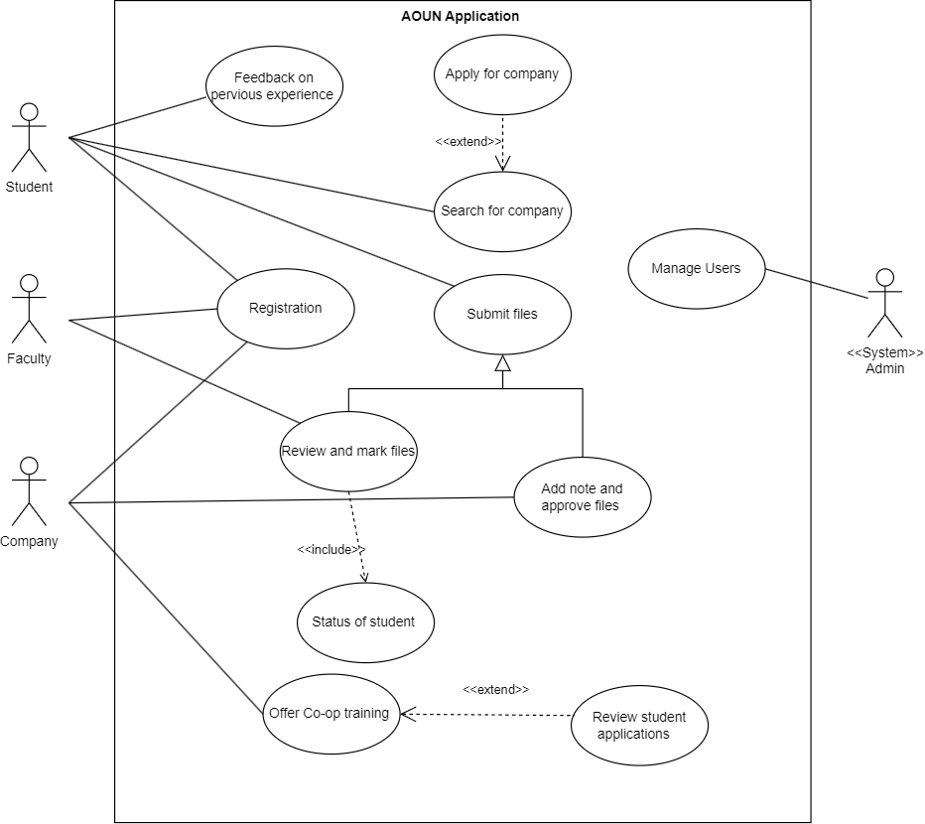

Figure 9: AOUN use case.

### 3.4.2 Use Case description

|  |  |  |
| --- | --- | --- |
| **Importance Level:** High | **ID:** 1 | **Use Case Name:** Registration |
| **Use Case Type:** Detail, Essential | | **Primary Actor:** Student, Faculty, Company. |
| **Stakeholders and Interests:**  Students: Seeking to register for co-op training opportunities.  Faculty: Register in order to evaluate student performance during co-op programs.  Company: Registering Looking to offer co-op training positions. | | |
| **Brief Description:** A user will apply for access to the website, user entry will be gathered, an account will be created and will allow for future access. | | |
| **Trigger:** The user enters the website and clicks on registration button.  **Type:** User Action. | | |
| **Relationships:**  **Association:** Student, Faculty, Company  Include:  Extend:  Generalization: | | |
| **Normal Flow of Events:**   1. Enter website. 2. Click on the registration button. 3. Enter name, e-mail, and password. 4. User has been registered. | | |
| **SubFlow:**   * Log In if the user has an account already created. | | |
| **Alternate/Exceptional Flows:**   * If user has been previously registered an error message will display. | | |

Table 3:Registration use case.

|  |  |  |
| --- | --- | --- |
| **Importance Level:** Medium | **ID: 2** | **Use Case Name:** Feedback On previous experience |
| **Use Case Type:** Detail, Essential | | **Primary Actor:** Student |
| **Stakeholders and Interests:**  **Student:** The students can write their previous experience | | |
| **Brief Description:** To help other students make informed decisions about co-op opportunities by sharing personal experiences with different companies. | | |
| **Trigger:** The student completes their co-op training and receives an invitation or prompt from the Aoun application to share their experience.  **Type:** User Action | | |
| **Relationships:**  **Association:** Student  **Include:**  **Extend:**  **Generalization:** | | |
| **Normal Flow of Events:**   1. The student logs into the Aoun application. 2. The student navigates to the "Feedback" section dedicated to sharing experiences from completed co-op placements. 3. After filling out the form, the student submits their feedback by clicking the "Submit" button. 4. The submitted experience is added to the database and displayed on the relevant company's profile within the application. | | |
| **Sub Flow:** | | |
| **Alternate/Exceptional Flows:**   * The student tries to submit feedback for the same co-op experience more than once. * The student tried to submit the experience form, but he didn't finish the Cc-op Training | | |

Table 4: Feedback use case.

|  |  |  |
| --- | --- | --- |
| **Importance Level:** High | **ID: 3** | **Use Case Name:** Search for company |
| **Use Case Type:** Detail, Essential | | **Primary Actor:** Student |
| **Stakeholders and Interests:**  **Student:** The student searches for company to find Co-op Training. | | |
| **Brief Description:** This use case enables students to easily search and access details about companies offering co-op training, enabling them to find opportunities that align with their career aspirations. | | |
| **Trigger:** The student logs and then accesses the co-op search feature within the Aoun app.  **Type:** User Action | | |
| **Relationships:**  **Association:** Student  **Include:**  **Extend:** Apply for company  **Generalization:** | | |
| **Normal Flow of Events:**   1. The student logs into the Aoun application. 2. The student accesses the co-op search feature within the Aoun app. 3. The system generates a list of companies. 4. If a student is interested, they can select a company from the list to explore opportunities and apply for a co-op position or continue to search for other companies. | | |
| **Sub Flow:**   * The student filters the opportunities that the companies offer. | | |
| **Alternate/Exceptional Flows:**   * The student's search criteria yield no matching results. | | |

Table 5: Company search use case.

|  |  |  |
| --- | --- | --- |
| **Importance Level:** High | **ID: 4** | **Use Case Name:** Submit files |
| **Use Case Type:** Detail, Essential | | **Primary Actor:** Student |
| **Stakeholders and Interests:**  **Student:** The students can Submit the required Files | | |
| **Brief Description:** The student submits the required files and waiting for approval form the company trainer and the marks form the faculty. | | |
| **Trigger:** The student completes filling the required files for their co-op and is ready to submit them for approval and review.  **Type:** User Action | | |
| **Relationships:**  **Association:** Student  **Include:**  **Extend:**  **Generalization:** Faculty and company | | |
| **Normal Flow of Events:**   1. The student logs into the Aoun application. 2. The student navigates to the section of the application that is intended for submitting files. 3. The student click on the file must submitted. 4. The student inputs the details of the file and the click on "Submit File". 5. The system processes the files, registers the submission, and sends a confirmation email to the student. | | |
| **Sub Flow:**   * The student waits for feedback and approval from the company trainer and the mark from faculty. | | |
| **Alternate/Exceptional Flows:**   * The student attempts to upload files that exceed the system's maximum allowed file size. | | |

Table 6: File submission use case.

|  |  |  |
| --- | --- | --- |
| **Importance Level:** High | **ID:** 5 | **Use Case Name:** Offer Co-op training |
| **Use Case Type:** Detail, Essential | | **Primar Actor:** Company |
| **Stakeholders and Interests:** Company looking to offer co-op training opportunity, enhancing a company’s reputation. | | |
| **Brief Description:** Company uses the application seeking to offer co-op training positions to students, procuring talent benefiting companies and students. | | |
| **Trigger:** The company user clicks on offer training positions, publishing co-op training positions.  **Type:** User Action. | | |
| **Relationships:**  **Association:** Company  Include:  Extend: Review student application.  Generalization: | | |
| **Normal Flow of Events:**   1. Click on offer co-op training positions. 2. Fill in details about the position. 3. Confirm posting details making it available for student to apply for. 4. Review applications. 5. Select suitable candidates. 6. Offer Acceptance. | | |
| **SubFlow:**   * Company rejected students’ applications. * Rejection notification to applicants. * Company requires the conduction of an interview; an interview will be scheduled. | | |
| **Alternate/Exceptional Flows:** | | |

Table 7:Offer co-op use case.

|  |  |  |
| --- | --- | --- |
| **Importance Level:** High | **ID:** 6 | **Use Case Name:** Manage Users |
| **Use Case Type:** Detail, Essential | | **Primar Actor:** System admin |
| **Stakeholders and Interests:** Efficiently manage the stakeholders accounts. | | |
| **Brief Description:** System admin handling user accounts, facilitating secure account management. | | |
| **Trigger:** System admin manages accounts by create, update, delete actions.  **Type:** State Change. | | |
| **Relationships:**  **Association:** System  Include:  Extend:  Generalization: | | |
| **Normal Flow of Events:**   1. System administrator logs in. 2. Verify admin privileges. 3. Navigate to account management. 4. List of all users 5. Perform create, update, delete actions. 6. Confirm changes occurred. | | |
| **SubFlow:** | | |
| **Alternate/Exceptional Flows:**   * During performance of operations where the case might be that an error has occurred, the system will display an error message. * The admin will perform actions for error handling. | | |

Table 8:Manage users use case.

## 3.5 Non-functional Requirements

1. **Availability:**
2. The system Must be available 24/7.
3. The system must be available for all web browsers.
4. **Security**
5. The system must give access only to the authorized users.
6. The system must protect the privacy of stakeholders’ information.
7. **Performance**
8. The system should respond to requests within 5 second.
9. The system could handle up to 300 concurrent users.
10. **Maintenance**
11. The system should be maintained each semester.

# Chapter 4: SYSTEM design

**4.1 System Modelling**

This chapter offers an overview of the system's structure, behavior, and data management by presenting detailed diagrams and descriptions of key workflows (activity diagrams for main use cases), system components and their interactions (class and sequence diagrams), data organization and relationships (ER diagram with normalization and data dictionary), and user interfaces (screen dumps with descriptions explaining their design and purpose), all aimed at ensuring the system is intuitive, efficient, and meets the functional requirements.

**4.1.1 Activity diagrams**

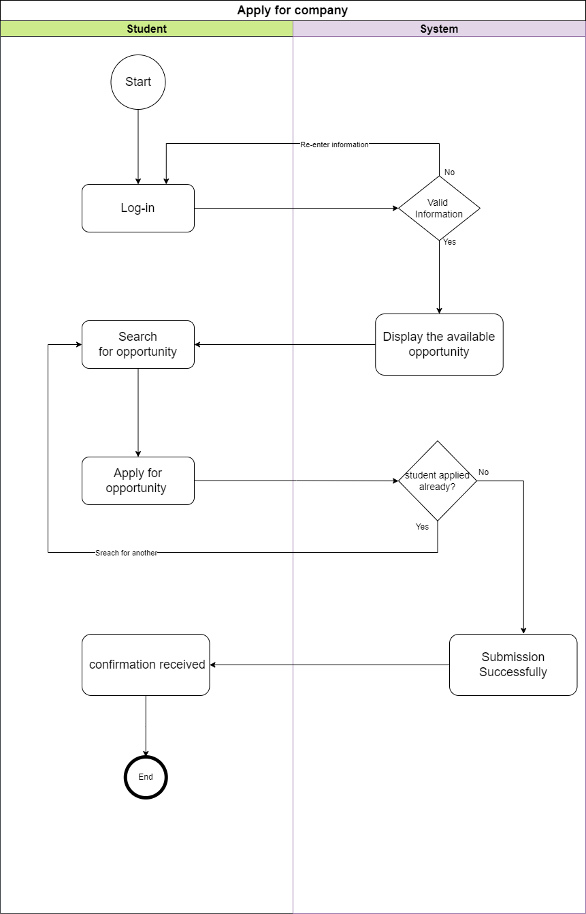

Figure 10: apply for coop

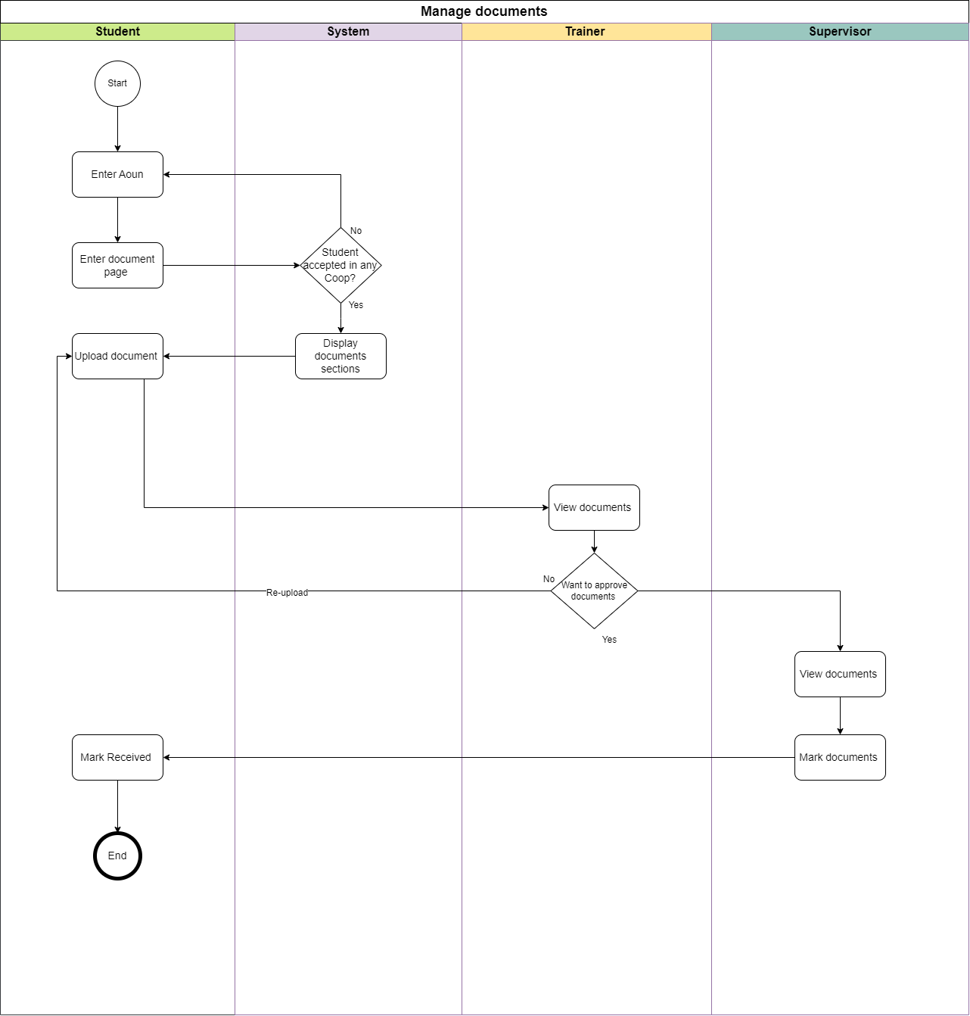

Figure 11: Manage documents

**4.1.2 Class Diagram**

**4.1.3 Sequence Diagrams**

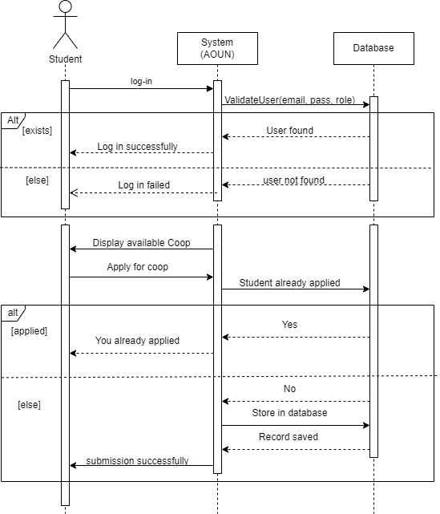

Figure 12: apply for coop

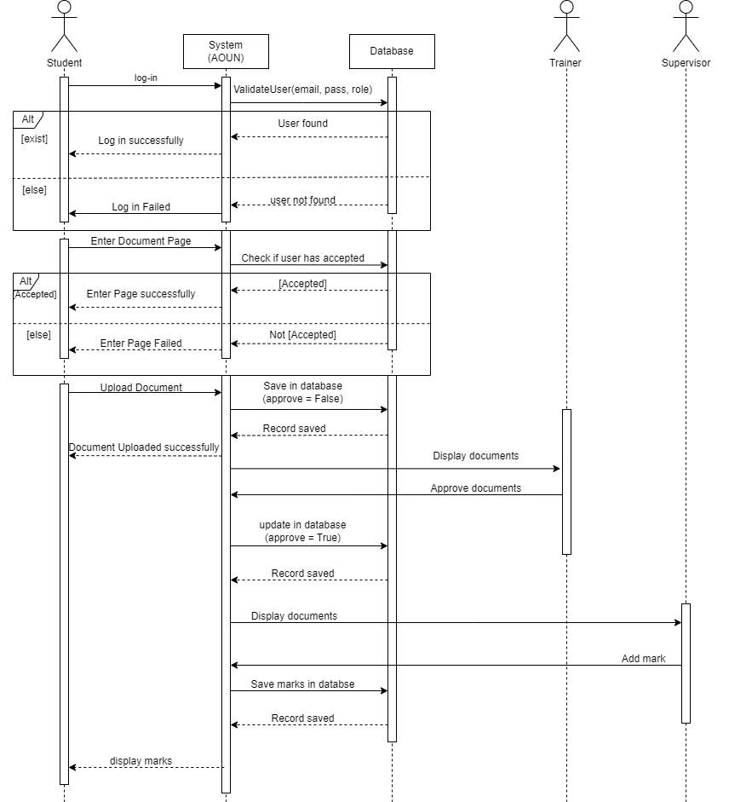

Figure 13: manage documents

**4.2 Data Modelling**

**4.2.1 ER Diagram**

[Provide ER diagram after performing normalization]

**4.2.2 Data Dictionary**

**4.3 Detailed Interface Design**

[Screen dumps for input and output interfaces with their small description and purpose to design.]

**4.4 Component Diagram [optional]**

[Show the software component or modules and their dependencies.]

# Chapter 5: System Implementation

**5.1 System Specification**

**5.1.1 Hardware Specifications**

[List recommended hardware specifications for your system from user point of view and provide justifications]

**5.1.2 Software Specifications**

[List recommended software specifications for your system from user point of view and provide justifications]

**5.2 System Testing**

**5.2.1 Features to be tested**

**5.2.2 Test Cases**

[Purpose, Inputs, Expected outputs, Pass/Fail criteria, test results]

**5.3 System Deployment**

**5.3.1 Deployment Diagram**

[Shows how the software component, processes and objects are deployed into the physical architecture of the system.]

**5.3.2 Expected Users/Load**

**5.3.3 Installation Process**

# Chapter 6: Conclusion and Future Work

**6.1 Conclusion**

[Discuss the results you got and the obstacles you have face during the project different phases. Explain how you overcome these obstacles (training, self learning, etc) and Summarize what was learned and how it can be applied.]

**6.2 Future Work**

[Discuss possible extensions to your work in the future]

# References

[1] National Association of Colleges and Employers, "The impact of cooperative education on job placement and starting salaries," 2020.

[2] Journal of Vocational Education & Training, "Benefits of cooperative education for organizations: Employee retention and performance," 2019.

[3] Field Training System," Imam Mohammad Ibn Saud Islamic University, [Online]. Available: <https://fieldtraining.imamu.edu.sa/>.

[4] Hayerd. (2024). [Online]. Available: <https://hayerd.com/>

[5] "draw.io," [Online]. Available: <https://www.draw.io/>.

[6] D. Clegg and R. Barker, Agile Project Management Using MoSCoW Prioritization: A Comprehensive Guide, 2nd ed. London, UK: Apress, 2021. pp. 34-56.

# Appendix

## A. Questionnaire results

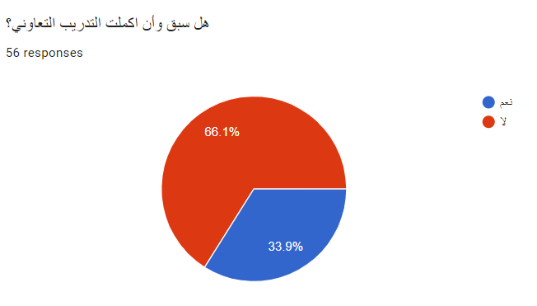

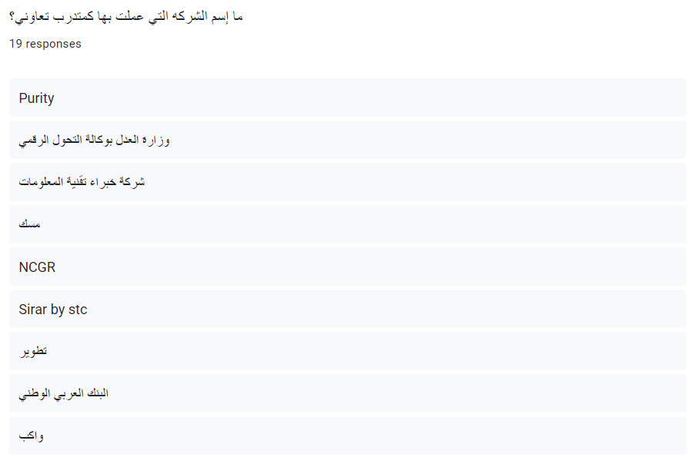

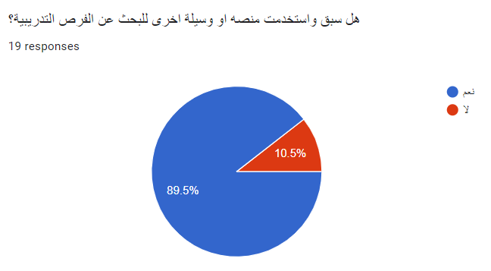

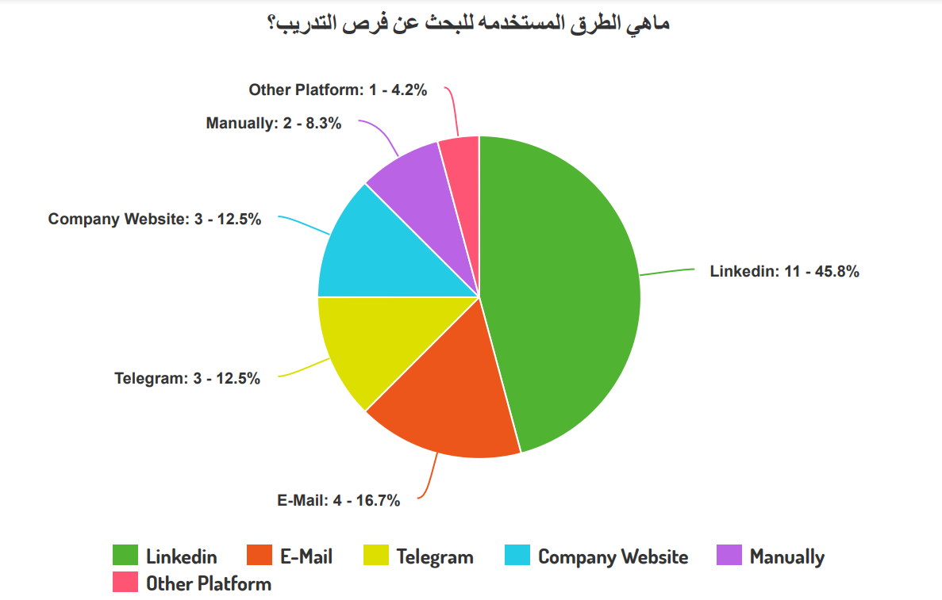

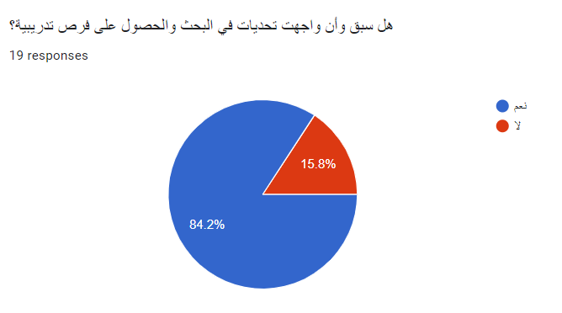

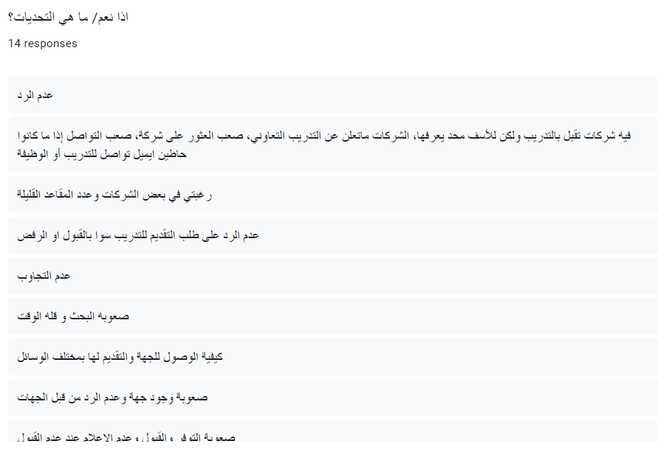

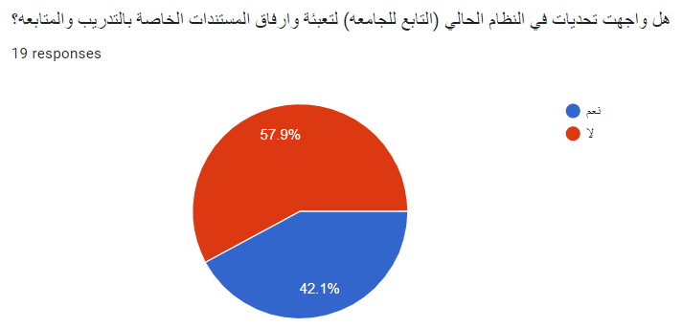

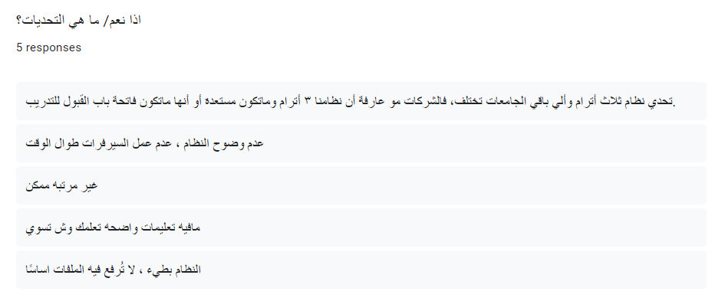

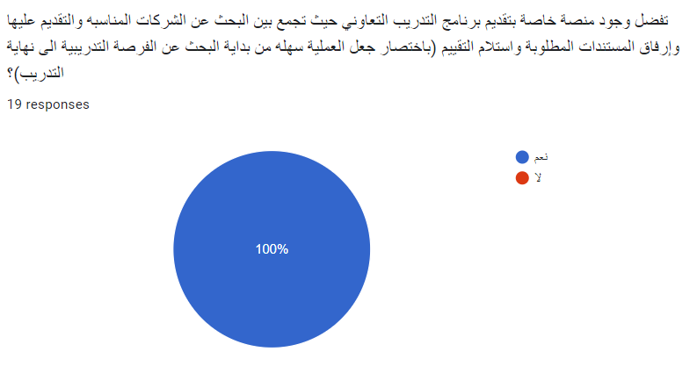

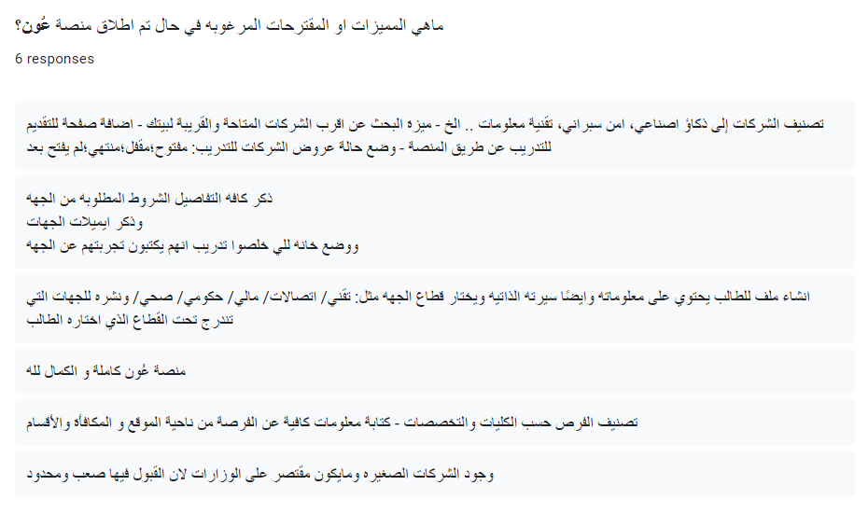

# A. Miscellaneous

|  |  |
| --- | --- |
| **Faculty Interview Form** | |
| 1. **Name:** |  |
| 1. **Position/Role:** |  |
| 1. **Department:** |  |
| 1. **Date:** |  |
| Supervision Experience   1. Have you ever supervised a student in cooperative training?    * If yes, please provide details of your experience.   Challenges and Difficulties   1. What are the difficulties and challenges you faced during the period of supervising a cooperative training student?   Current System Evaluation   1. What is your view of the current system during the cooperative training period in terms of delivery of weekly documents and other documents?   Credibility Issues   1. Do you think that there is a lack of credibility in the attendance and departure of students in the area in which they are trained?   Solutions   1. From your point of view, what is the appropriate solution to the problems mentioned?   Expectations from Aoun Website   1. What are your expectations for the characteristics and features that the Aoun website will provide? 2. Do you think that the Aoun website will facilitate the process of searching for training for the student and will also facilitate the process for supervisors of accessing the documents that the student has attached and that will be certified by the trainer?   Long-term Benefits   1. What long-term benefits do you expect from implementing a collaborative training application for students, faculty members, and employers?   Additional Features   1. What are the features or additions that you would like us to take into consideration on the Aoun website that will be an enriching addition to the site? | |

Table 9: Faculty interview form

|  |  |
| --- | --- |
| **Company Interview Form** | |
| 1. **Company Name:** |  |
| 1. **Representative's Name:** |  |
| 1. **Position/Role:** |  |
| 1. **Department:** |  |
| 1. **Date:** |  |
| Training Experience   1. Have you previously trained cooperative training students in the region?    * If yes, can you mention any memorable experiences?   Training Volume   1. Approximately how many students do you train in a year?   Recruitment Methods   1. What are the methods and procedures for presenting cooperative training opportunities?   Recruitment Challenges   1. Do you face difficulties in finding students for cooperative training based on your training requirements?    * If yes, please elaborate on these difficulties.   application Utility   1. Do you think that if you had an application to display your cooperative training opportunities, also to accept applications and schedule interviews, and have documents uploaded, it would facilitate an easier process for you?   Desired Features   1. What are the features or additions that you would like us to take into consideration on the Aoun website that will be an enriching addition to the site? | |

Table 10: Company Interview Form

# B. Code Snippets

[1. Provide codes for implementing 3 major use cases of your project.

2. Queries used for report generation/display of summarized data along with brief description of the queries.]

# B. Presentation Slides

# D. Poster

[fit in one page]

1. Write down your responsibilities in the project
2. Must add to 100%